# 📘 My English Hub

### English for Explorers – On the go!

**Travel Talk**

Welcome to another session of My English Hub with Katty. This time we are going to start a four-session series about one of our favourite topics... travelling.

In this series, we’ll focus on to enhancing our speaking skills through practical, real-life travel situations. Each session combines useful vocabulary, key expressions in context, and interactive dialogues that we can use on our own adventures.

Whether we're planning a trip on a budget, booking accommodation, navigating transportation, or connecting with locals, these sessions will empower us to communicate confidently wherever we go.



**Session Topics:**

1. **Budget Travel: Smart Ways to Save on the Road**  
   Tips, recommendations, and useful dialogues for situations like arriving at a hostel and asking for tourist information.
2. **Accommodation Adventures: Booking and Check-In Essentials**  
   Learn how to book your stay, negotiate accommodations, and handle check-in processes smoothly.
3. **On the Move: Navigating Transportation and Asking for Directions**  
   Practice the vocabulary and expressions needed for airports, train stations, and using local transit.
4. **Cultural Connections: Dining Out, Socializing, and Local Experiences**  
   Explore essential phrases for ordering food, interacting with locals, and making the most of cultural encounters.

**Session 1**  
**Budget Travel: Smart Ways to Save on the Road**

Welcome to the first session of our "Travel Talk: English on the go" series!

Today, we’re into the world of budget travel. Our focus is on enhancing your speaking skills through practical, real-life scenarios. We'll learn key vocabulary and expressions, and practice dialogues that you can use when checking into a hostel, asking for tourist information, negotiating prices, and more. Get ready to build your confidence and fluency while exploring smart travel tips!

The article offers a comprehensive guide for budget-conscious travelers in Europe. It emphasizes that with smart planning and a flexible attitude, you can explore Europe without overspending.

**Key Points:**

* **Plan Ahead & Be Flexible:**
  + Research and book early to snag the best deals on flights and accommodations.
  + Flexibility with travel dates and destinations can lead to significant savings.
* **Transportation Options:**
  + Compare budget airlines, buses, and trains to find the most cost-effective ways to travel between cities.
  + Utilize travel apps and websites to monitor price drops and special offers.
* **Affordable Accommodations:**
  + Consider hostels, budget hotels, or alternative options like Airbnb.
  + Look for places that offer additional benefits (e.g., free breakfast) to reduce overall costs.
* **Eating & Entertainment on a Budget:**
  + Save money by dining where the locals do—think street food, local markets, or small eateries.
  + Explore free or inexpensive attractions, such as walking tours, public parks, and museums with discounted or free entry days.
* 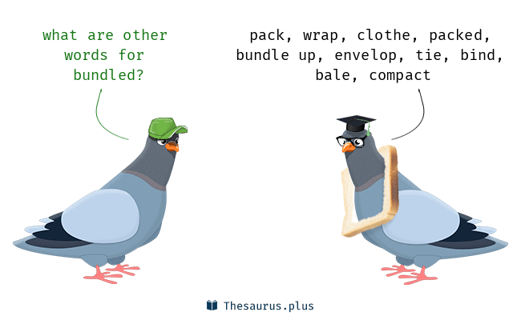**Money-Saving Strategies:**
  + Use travel passes, discount cards, or city tourism cards which can offer bundled savings on attractions and transport.

Budget your daily expenses in advance to avoid overspending.

For more details and additional tips, you can check out the full article on Happy To Wander: [Cheapest Way to Travel Europe](https://happytowander.com/cheapest-way-to-travel-europe/)

**Chat Part**

1. What is one takeaway from the article that you could apply to your own travel planning or even your everyday budgeting?
2. How do you feel about the idea of planning every detail of your trip versus leaving room for spontaneous adventures?
3. When you plan a trip, do you usually consider recommendations like those in the article?
4. Which cost-saving tip mentioned (or implied) in the article do you think would be most challenging for you to implement, and how might you overcome that challenge?
5. How do you balance the need to save money with the desire for comfort and convenience when you travel?

***And now... let's go back to our practice.***

**Are you ok with this Vocabulary?**

* **Budget:** Affordable, cost-effective
* **Hostel:** Low-cost accommodation
* **Discount:** A reduction in price
* **Itinerary:** A detailed travel plan
* **Backpacker:** A traveler on a tight budget
* **Negotiation:** Discussing prices or deals
* **Local:** A resident of the area
* **Tourist Information:** Guidance on local attractions, maps, and tips

**What about these common phrases?**

* “Could you please help me with…?”
* “I’m looking for a budget-friendly option.”
* “Do you have any recommendations for…?”
* “How much does it cost for…?”
* “Is there any discount available?”

*Let's act a bit!*

**Dialogue 1: Arriving at a Hostel**

* **Receptionist:** “Welcome to Sunrise Hostel. How can I help you today?”
* **Traveler:** “Hi, I have a reservation under [Your Name]. Can I check in, please?”
* **Receptionist:** “Certainly. May I see your ID and booking confirmation?”
* **Traveler:** “Here they are. Also, could you tell me if you offer any budget meals for guests?”
* **Receptionist:** “Yes, we have a breakfast special and a discounted dinner option available.”
* **Traveler:** “Great, thanks for the information!”

**Dialogue 2: Asking for Tourist Information**

* **Traveler:** “Excuse me, could you help me? I’m looking for affordable local tours.”
* **Tourist Information Officer:** “Of course! What kind of tour are you interested in?”
* **Traveler:** “I’d like a walking tour of historical sites, but I’m on a tight budget.”
* **Tourist Information Officer:** “You might enjoy our free guided tour that starts at the city square. There are also discount tickets for several museums.”
* **Traveler:** “That sounds perfect. Thank you so much!”

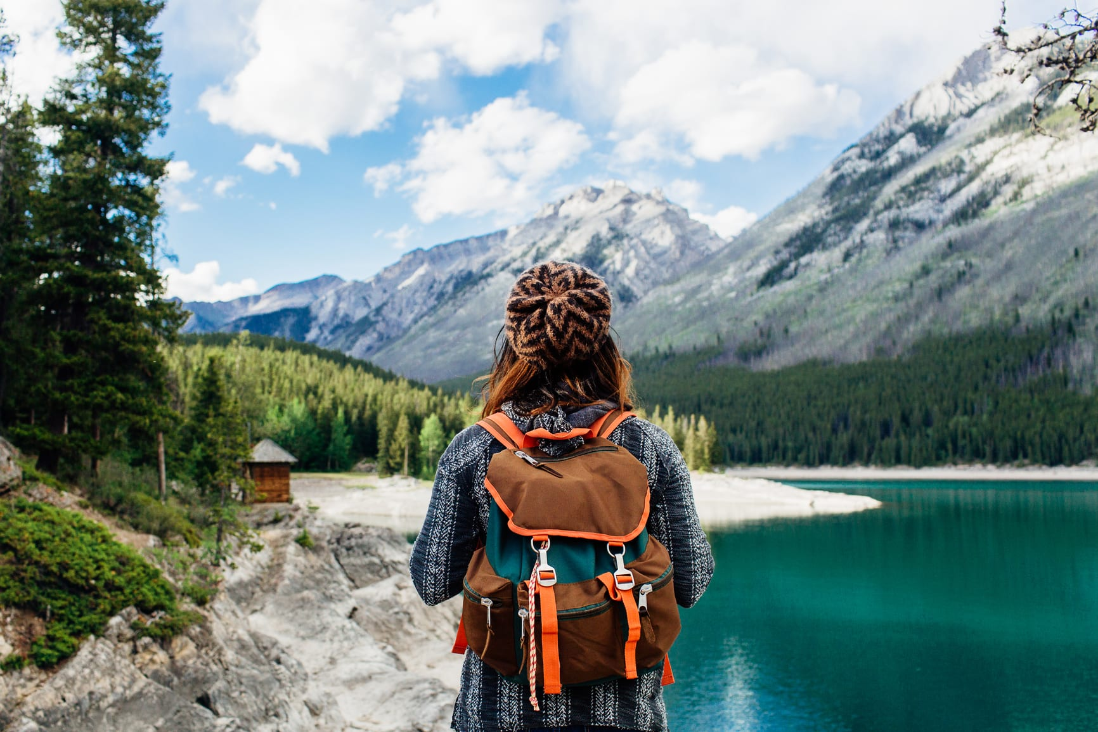

## 📲 Keep growing with us

👉 Ask us about the full program  
👉 Join live conversation sessions  
👉 My English Hub – where real English happens